INDIAN INSTITUTE OF MANAGEMENT, KOZHIKHODE

Title: Integrated model for aircraft routing & maintenance planning.
Research Advisory Committee:
Prof. P. N. Ram Kumar (Chairperson, RAC)
Asst. Prof. Ramesh Krishnan (Area member, RAC)
Asst. Prof. Dharun Kasilingam (Cross Area member, RAC)

Submitted by:
Arun Kumar Pappala
PhDPT03/24/Q

Abstract
Aircrafts are the most expensive resources in an airline enterprise. The optimal deployment of this valuable resource starts with assigning aircraft to schedule. Arriving at an optimal number of aircraft needed to sustain the operations of a published schedule will greatly help in reducing aircraft leasing costs, utilization of maintenance resources, or even adjusting schedules strategically. In addition, the aircraft assignment must take into account the standard maintenance considerations (A/B/C/D-checks) at planning stage to increase schedule compliance; avoid penalty costs & ensure safety.

KEYWORDS: Aircraft Routing, Maintenance planning, Integrated airline planning, Integer Linear Programming, Heuristics

Introduction
The airline industry is a very key economic driver for any country. The GDP of a country is truly reflected in the air traffic volumes of the country. However, airline industry is a very low margin business. Constructing a profitable schedule is at the heart of the airline operations. The airline market demand, the prevailing government regulations & various strategic decisions impact the operated destinations and frequency of flight operations. This choice of destinations and frequency comprise the schedule. Publishing a 10% more optimal schedule will improve revenues by 1%. Knowing the profit margins of airline industry is typically 1-3% average over the last decade; any revenue improvement without additional resources will translate into higher profits. Hence, effective planning and scheduling becomes highly pivotal to airline success.
Typically, the schedule planning process consists of the following steps: flight scheduling, fleet assignment, aircraft routing, maintenance planning and crew scheduling. Ideally there must be integration between schedule design, fleet assignment, aircraft routing, maintenance planning and crew pairing to achieve optimal operations [FA19-Pony et.al]. The schedule design phase will fix the destinations to fly and the frequency (weekly, daily, twice-daily etc.) based on airport slot availability and demand forecasts. The fleet assignment stage will allocate the fleet-type to each flight route. such that the capacity of the aircraft closely matches the expected demand on the route; this step will ensure there is no seat.
The existing literature either disaggregates the scheduling problem into several modular subproblems or assumes some critical dependencies as input due to the trade-off between tractability and profitability. Such siloed handling of schedule planning processes as modular sub-problems will decrease the optimality of the overall solution. Most work further assumes the cyclic-schedule operation and plan for a day, few days or a week.
The main product of an airline is the Schedule. An operable and maintainable schedule which is robust against disruption can help improve performance & revenues. The biggest adhoc cost drivers for airlines are cancelled flights, & unused maintenance slots. Both costs can be reduced by improved maintenance planning. Increased robustness of the schedule & maintenance plan to disruptions can both increase revenue & decrease costs; thereby improving the margins for the airline.
The planning stage ends with schedule publication. The schedule is basically a combination of the routes and the dates for each flight the airline will operate. This is the product that airline will publish to the market and that will drive consumers to book the flights published on the schedule. Normally the entire seasonal schedule is seldom viewed by normal passengers as the website will focus the search via the desired travel dates and routes. However, an exhaustive schedule for the flight airline will operate for the next six to eight months will be typically published.
Sample published schedule is as follows:
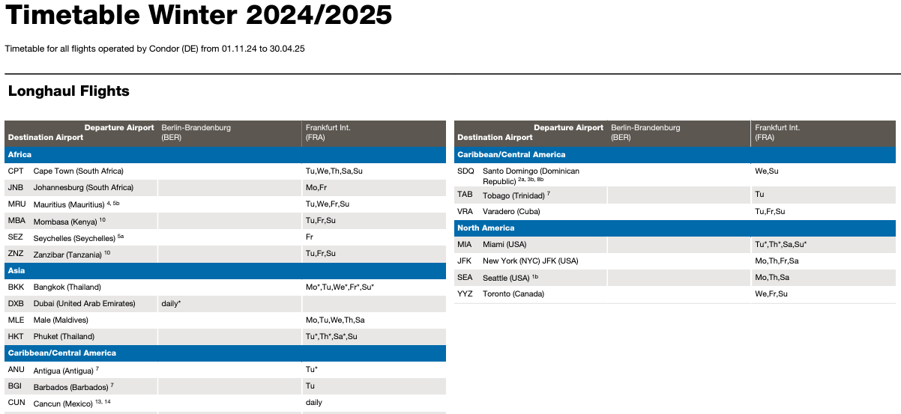
Here is another schedule publication with date of operations & timings:
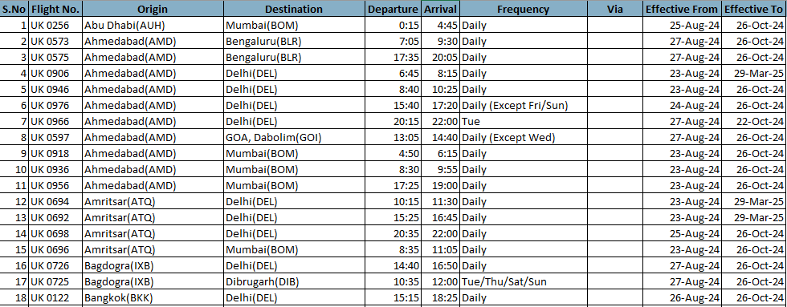
The published schedule will then be assigned fleet and actual aircraft rotation, as part of operations. The assignment of aircraft to the above flights must be done in the most optimal manner so as to maximize the aircraft usage and also reduce the total number of aircraft needed to operate the schedule.
Such assigned of aircraft to flights can be represented as follows:
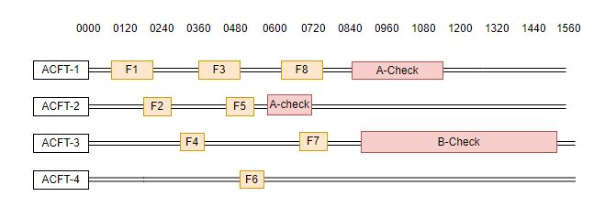
The above figure shows the allocation of flights to aircraft.

Then the aircraft allocation must also take into account there are no deadhead flights, or the routing bring the aircraft to a city where maintenance can be undertaken at the time when such maintenance is due. Here the city/station-based allocation of aircraft to respective flights is shown.
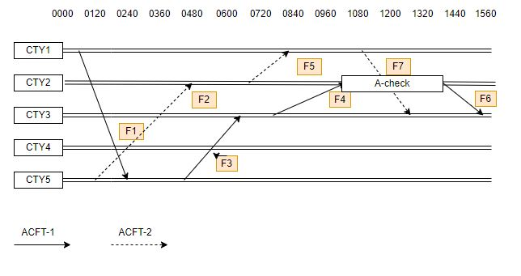

Literature Review

Aircraft Routing
Most of the current literature addressed the aircraft routing problem at a day/week level and treated it as an operational activity. Banhart.et.al (1998) proposed a column generation approach to assign aircrafts to a schedule but limited to weekly flights and considered inherent regular overnight maintenance. This was improved by Chellappan et.al (2003) with proposing another weekly aircraft assignment with maintenance considered for A-check; This was improved by Sarac et. al (2006) to include maintenance feasibility by considering slots and capacity using branch and price algorithm for a daily time horizon. Later Houari et. al (2009) integrated the fleet assignment with aircraft routing; where heuristics were deployed to solve both fleeting & routing simultaneously. The deadhead costs, and aircraft assignment costs are minimized here, and the time horizon was up to 3weeks. This was further enhanced by Sherali et.al (2013) towards an integrated schedule design, fleet planning & aircraft routing model using Bender’s decomposition. This work considered itinerary based demands, maintenance considerations etc. during optimization. Then Kenan et.al (2018) significantly enhanced the aircraft routing problem with optional flights and delay considerations. This work considered stochasticity of demand, optional flights, delays and deadhead flights were considered. The Column generation approach was used to solve the problem while also addressing demand uncertainty. A similar integrated scheduling and routing with cruise control considerations was published by Gurukan et.al (2016). This work used non-linear programming with heuristics to optimize the best routing plan with lowest CO2 emission cost too. A longer horizon planning for aircraft routing was published by Oumaima et. al (2018) by considering only A-check maintenance. More recently Ben Ahmed et. al (2022) have included crew planning also into this integrated scheduling and aircraft routing solution. Maintenance task planning and resourcing was simultaneously addressed with robustness while considering disruption sources like propagated delays, adhoc maintenance tasks etc. in the work by Yonghuan et. al (2023). The latest work to handle aircraft routing and maintenance for a longer horizon of 4 days implements both linear model and also a reinforcement learning model by Ruan et.al (2023).

Aircraft Maintenance
In addition, maintenance planning has been separately worked upon, to plan maintenance at the right moment of reaching the thresholds of flying hours, days etc., by Mehmet. Et.al (2013). This work used compressed annealing technique to reduce the remaining flying hours by scheduling the check as late as possible. Later the work by QichenDeng et. al (2019) has explored long term maintenance scheduling (A & C checks) using dynamic programming. This work also handles minimizing the disruptions due to schedule changes. Later Xin Wen et. al (2022) have developed a column generation method to solve for both maintenance plan & aircraft routing plan with all maintenance capacity constraints addressed. However, this is for a four-day time horizon.

The literature review of related studies is shown below:

Sl.No | Authors | FSP | FAP | ARP | Maint’n resources | Maint'n checks | Cyclic Constr. | Max-days | Objective Function
1 | Kenan N et. al (2018) | N | Y | Y | N | None | Y | 1 | Max profit
2 | Xu, Yifan et al (2021) | Y | Y | Y | N | None | Y | 7 | Max profit
3 | Ben Ahmed et al, (2022) | N | Y | Y | N | None | Y | 2 | Max profit
4 | Hüseyin et al (2016) | Y | Y | Y | N | None | Y | 1 | Min (Task outstanding, delays)
5 | YongHuan He et al (2023) | N | N | Y | Y | None | Y | 7 | Min proppagated delays
6 | Axel P et al (2020) | N | N | Y | N | None | Y | 7 | Min resource costs
7 | K.Gulnaz Bulbul et al (2021) | N | N | N | Y | A only | Y | 1 | Zero maintenance violation
8 | J H Ruan et al. (2023) | N | N | Y | Y | None | y | 4 | Max profit
9 | Oumaima Khaled et al (2018) | N | N | Y | Y | A only | No | 30 | Min resource costs
10 | Xingye et al (2019) | N | Y | Y | N | A only | Y | 1 | Min nbr of aircrafts
11 | Mehmet Bas et al (2013) | N | N | Y | Y | A only | Y | 7 | Min unused flying hrs.
12 | Q Zhand et al (2024) | N | N | Y | Y | A only | N | 30 | Min total delay costs
13 | Emine Es Yure (2024) | N | N | Y | N | A only | Y | 7 | Min unused flying hrs.
14 | Xin Wen et al (2022) | N | N | Y | Y | A only | Y | 1 | Min resource costs

Research Gap
From the above table, it is clear, the cyclic constraint is assumed in most studies thereby limiting the solution to be applicable only on repeated flight scheduled only. Hence the optimizations must be repeated multiple times and also whenever there is a deviation to the schedule. This happens more often as airlines now operate schedules to address seasonal & event-based demand.
Airlines often adjust their schedules to accommodate increased demand during major festivals and events, adding temporary or seasonal routes. Here are some examples of flight schedules that have been operated specifically for festivals and events:
- 1. Hajj Pilgrimage Flights (Various Airlines)
- Airlines: Saudia, Emirates, Qatar Airways, Turkish Airlines, and many others
- Operation Period: Around the annual Hajj pilgrimage season (approximately 10 days before and after the event)
- Routes: Various routes from major Muslim countries and cities to Jeddah (JED) and Medina (MED), Saudi Arabia
- Details: Airlines worldwide increase flight frequencies or add special charter flights to accommodate pilgrims traveling to Saudi Arabia for Hajj. For example, Saudia often operates extra flights from cities like Jakarta, Kuala Lumpur, and Cairo to Jeddah.
- 2. Delta Air Lines: Atlanta (ATL) to New Orleans (MSY) for Mardi Gras
- Operation Period: Late February to early March (dates varies annually)
- Frequency: Increased flights, sometimes hourly, during peak Mardi Gras days
- Aircraft: Mixture of narrow-body aircraft such as Boeing 737 and Airbus A320 series
- Details: Delta typically adds more flights from Atlanta to New Orleans to cater to the influx of tourists attending the Mardi Gras festivities, one of the largest and most famous events in the United States.
- 3. Qatar Airways: Doha (DOH) to St. Petersburg (LED) for the FIFA World Cup 2018
- Operation Period: June to July 2018 (during the FIFA World Cup)
- Frequency: Daily or multiple times per week, adjusted based on match schedules
- Aircraft: Boeing 777 and Airbus A350
- Details: Qatar Airways introduced special flights to various Russian cities, including St. Petersburg and Moscow, to cater to football fans traveling to watch the FIFA World Cup matches.
- 4. Singapore Airlines: Singapore (SIN) to Ahmedabad (AMD) for Diwali
- Operation Period: Around October-November (dates vary annually with the Hindu calendar)
- Frequency: Additional flights or larger aircraft deployed to meet demand
- Details: Singapore Airlines often increases flights to cities in India, like Ahmedabad and Mumbai, during Diwali, the Hindu festival of lights, due to the high travel demand from Indian expatriates and tourists.
- 5. Turkish Airlines: Istanbul (IST) to Sarajevo (SJJ) for Eid al-Fitr
- Operation Period: Around the end of Ramadan (dates vary annually)
- Frequency: Extra flights scheduled in the days leading up to and following Eid al-Fitr
- Aircraft: Narrow-body aircraft like Airbus A321 and Boeing 737
- Details: Turkish Airlines increases flights to destinations with significant Muslim populations, such as Sarajevo, to accommodate travelers visiting family and friends for the Eid celebrations.
Hence this is one key gap addressed in this study; to be able to assign aircraft rotation considering all the specificities for the given season/period; thereby providing a more optimal schedule.

Further all the maintenance checks are not included in the schedule planning stage thereby limiting the practical implementation of the models in real operations. Currently at the operational window stage, the actual maintenance checks due will be allocated and the aircraft will be taken out of the schedule. This happens quite often, and the original planned aircraft rotation will have to be adjusted accordingly. This is one of the main reasons why the aircraft assignment is considered an operational activity and not a planning activity. By integrating the aircraft assignment into the planning stage.
    - The high certainty in planning can reduce the reserve aircraft needs thereby reducing cost.
    - The airlines can achieve more certainty in the operational window, thereby improving timeliness & brand image.
    - There will be lesser crew disruptions since the aircraft rotation is planned well ahead thereby improving employee engagement & reducing cost.

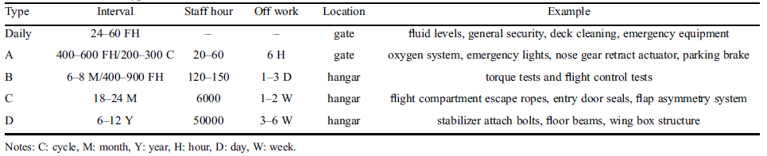
Above shown are the scheduled maintenance jobs that happen regularly as prescribed by manufacturers and regulators. Merging this maintenance plan with considerations to maintenance-station capacity & capability into the original schedule planning phase will vastly improve the effectiveness of the operations in terms of predictability & certainty.

Problem Description
Today airlines assign aircraft to a preexisting schedule while separately matching the maintenance needs as part of operations. Any shortage is met with leased aircraft. There is no integrated way of aircraft route planning and maintenance planning happening in today’s systems. Addressing this gap, this study aims to assign the aircraft to a given schedule and prepare the aircraft route plan while also taking into consideration all the maintenance checks scheduled based on existing maintenance slots/capacities. This way we will provide an aircraft route plan and also a maintenance plan, while also minimizing the number of aircraft needed to fulfill the schedule. Hence one of the key inspirations of the current work, to simultaneously provide an optimized aircraft routing plan & maintenance plan covering all checks (A, B, C, D) for the fleet applicable for the full season of 6 months.
The inputs for the proposed model will be the schedule for the next season, with fleet assigned; the number of aircraft available per fleet; the maintenance stations where each fleet type can be maintained with also the resource capacity per station. Input about the current aircraft flying hours since the last maintenance will also be provided.
The model will then optimize the aircraft route allocation to the schedule, bring the aircraft to the right maintenance station before the flying hours limit exceeds. In addition, the model will also minimize the number of aircraft needed to fulfill the schedule, thereby reducing any lease costs. The model allows staff to be flown to a maintenance location, if considered more economical. Otherwise, dead-head flights will be added to the schedule. The maintenance station capacity will be provided by man-hours per day; and this will be adjusted to meet the maintenance activity assigned to the station. This will result in both a routing plan per aircraft & a maintenance plan per station.
In addition, recommendations for an optimal maintenance station resource capacity and aircraft fleet capacity will be derived to fulfill the proposed schedule. This can also be used by airlines to make continue/exit decisions for leased aircraft.
The above model can be re-run during operational window with the necessary adjustments to fleet, stations etc. whenever a disruption occurs to reassess the most optimal route plan & maintenance plan with the new context of fleet, flights & maintenance needs.
Thus, our solution fulfils both the needs of a planning system and also an operational system.
Flight arcs – representing flights
Ground arcs – representing stationary aircraft
Maintenance arcs – representing time spent on maintenance

Model Description

- Sets and Indices

F=12…NF | denotes the set of scheduled flights, where NFis the total number of scheduled flights. The elements of Fare indexed by iand r
P=12…NP | denotes the set of individual aircraft, where NPis the total number of available aircraft. The elements of Pare indexed by j
A=12…NA | denotes the set of airports, where NAis the total number of airports in the network. The elements of Aare indexed by k.
M=12…NM⊆A | denotes the subset of airports equipped with maintenance facilities, where NMis the total number of maintenance-capable airports. The elements of Mare indexed by k.  Since every maintenance-capable airport is an airport, the subset relationship M⊆A
D=12…H | denotes the set of days in the planning horizon, indexed by d, where His the total number of days in the planning horizon.
C=ABCD | denotes the set of maintenance-check types, indexed by c.  Here,  - A= A-check,  - B= B-check,  - C= C-check,  - D= D-check
CFH=AB,  CCAL=CD, | denotes the set of flight-hour-based maintenance checks,  denotes the set of calendar-based maintenance checks.  C=CFH∪CCAL, CFH∩CCAL=∅.
FM=i∈F: qi∈M | denotes the subset of maintenance-eligible flights, i.e., the set of flights whose destination airport is a maintenance-capable airport.  Here,  qidenotes the destination airport of flight i,  M⊆Ais the set of maintenance-capable airports.  Therefore, only flights in FMare eligible to trigger maintenance activities
Fkarr=i∈F: qi=k, ∀k∈A  Fkdep=i∈F: oi=k, ∀k∈A | denotes the subset of flights arriving at airport k  denotes the subset of flights departing at airport k  - aris the arrival time of flight r,  - τis the minimum required turnaround time (or connection buffer),  - tis the reference time,  - Fkarr / Fk+is the set of flights arriving at airport k.  - Fkdep / Fk-is the set of flights departing at airport k.
Fk-t=r∈Fkarr: ar+τ≤t, ∀k∈A, t∈R+  Fk+t=r∈Fkdep: sr<t, ∀k∈A, t∈R+. | Fk-tdenotes the set of flights that have arrived at airport kand completed the required turnaround time before the reference time t.  Fk+tdenotes the set of flights departing from airport kbefore the reference time t.  oris the origin airport of flight r,  sris the scheduled departure time of flight r,  tis the reference time.
Fd=i∈F: didep=d, ∀d∈D  Fd=i∈F: diarr=d, ∀d∈D | set of flights operated on planning day d, where didepdenotes the departure day of flight i
Fd1d2=i∈F: d1≤didep≤d2, 1≤d1≤d2≤H | set of flights operated within a given planning interval be strictly between d1and d2
FkdM=i∈FM: qi=k diarr=d, ∀k∈M, ∀d∈D. | maintenance-eligible flights arriving at maintenance airport kon planning day d.

- Variables:
xij
gi,t-1,t,a
m(i,t-1, t,a)M
yimAyimB,yimC,yimD
hijAhijB,hijC,hijD
cijAcijBcijCcijD
diA , diB , diC , diD
Ai
Fj
zi
Cm
CompletedFlyingHoursik
CompletedFlightCyclesik
Complteddaysik
rcyclesi
rdaysi
rflighthoursi
MaxFlyingHoursik
MaxFlightCyclesik
Maxdaysik
δiAδiBδiCδiD
xij | xij=1,if flight i is assigned to aircraft j,0,otherwise, ∀i∈F, ∀j∈P.  binary flight-assignment decision variable: xij∈01
zijdc | zijdc=1,if aircraft j initiates maintenance check-c on day-d after flight-i 0,otherwise,  ∀i∈FM, ∀j∈P, ∀d∈D, ∀c∈C.  where  - FM= set of flights arriving at maintenance-capable airports,  - P= set of aircraft,  - D= set of planning days,  - C=ABCD= set of maintenance check types.
yjdc | yjdc=1,if aircraft j starts maintenance check c on day d,0,otherwise,∀j∈P, ∀d∈D, ∀c∈C  where  P= set of aircraft,  D= set of planning days,  C=ABCD= set of maintenance check types.  The binary restriction is  yjdc∈01, ∀j∈P, ∀d∈D, ∀c∈C.
vjdc | vjdc=1,if the maintenance requirement for check c is satisfiedfor aircraft j on day d,either by performing check c or a higher-level check,0,otherwise,∀j∈P, ∀d∈D, ∀c∈C.  vjdc∈01, ∀j∈P, ∀d∈D, ∀c∈C.vjdcis related to the maintenance-start variables as  vjdA=yjdA+yjdB+yjdC+yjdD,vjdB=yjdB+yjdC+yjdD,vjdC=yjdC+yjdD,vjdD=yjdD
wjkdc | wjkdc=1,if aircraft j occupies maintenance capacity atmaintenance airport k on day d while undergoingmaintenance check c,0,otherwise,∀j∈P, ∀k∈M, ∀d∈D, ∀c∈C.  where  P= set of aircraft,  M= set of maintenance airports,  D= set of planning days,  C=ABCD= set of maintenance check types.  wjkdc∈01, ∀j∈P, ∀k∈M, ∀d∈D, ∀c∈C.
ηcc' | ηcc'=1,if maintenance check c'satisfies the requirement of check c,0,otherwise.

- Input Parameters:
Flight Parameters
oi | Origin (departure) airport of flight i,
qi | Destination (arrival) airport of flight i,
si | Scheduled departure time of flight i,
ai | Scheduled arrival time of flight i.
ti=ai-si, ∀i∈F | Flight duration of flight i
diarr=ai1440+1, ∀i∈F, | Flight day of arrival; where 1440 is the minutes in one day
didep=si1440+1, ∀i∈F. | Flight day of departure; where 1440 is the minutes in one day

Aircraft Parameters
bj∈A, ∀j∈P, | denotes the initial airport (starting location) of aircraft jat the beginning of the planning horizon.
δjk=1,if bj=k,0,otherwise, ∀j∈P, k∈A, | denotes its initial airport of the aircraft
ujc0 | the initial accumulated utilization of aircraft jsince its last maintenance of type cat the beginning of the planning horizon  &For c∈CFH AB,&&ujc0 is measured in flight minutes.&For c∈CCAL CD,&&ujc0 is measured in calendar days.

Cost Parameters
gij | denotes the cost of assigning flight ito aircraft j
πc | denotes the cost of performing a maintenance check of type c

Airport Parameters
Qk | denotes the maximum number of maintenance activities that can be initiated at maintenance airport kon a given day

Maintenance Parameters
Kc | Maintenance days- duration of check-c
Rjc0 | remaining maintenance interval before check cbecomes due for aircraft j  Rjc0=Lc-ujc0, ∀j∈P, ∀c∈C
Lc | denotes the maximum allowable interval, measured in days, between two consecutive maintenance satisfactions of type c
hc | denotes the hours-duration of maintenance check c

Tj
TiMTiATiB, TiC, TiD​​

Cm:
maintenance requirementi
turnaroundTimeis
departureTimej
arrivalTimej
TcyclesATcyclesBTcyclesCTcyclesD
Tdays, minATdays,minBTdays,minCTdays,minD
Tdays, maxATdays,maxBTdays,maxCTdays,maxD
Tdays, maxATdays,maxBTdays,maxCTdays,maxD

- Objective Function:
minZ=i∈Fj∈Pgijxij+i∈FMj∈Pd∈Dc∈Cπczijdc

i=1Nzi
zi
Subject to Constraints:
Constraint Description | Notation
Flight coverage: Each flight must be covered by exactly one aircraft | j∈Pxij=1, ∀i∈F.i-1nxij=1
Aircraft-flow and initial-position feasibility  For every aircraft (j), airport (k), and flight (i) departing from airport (k), the aircraft must either have arrived previously or have been initially located at the airport | r∈Fk-sixrj-r∈Fk+sixrj+δjk≥xij, ∀j∈P, ∀k∈A, ∀i∈Fk+tdadtaaaadaatdtd  Here,  Fk-si=r∈F:ar=k er≤si  denotes the set of flights that arrive at airport kbefore flight ideparts, and  Fk+si=r∈F:or=k sr<si  denotes the set of flights that have already departed from airport kbefore the departure time of flight i.  The parameter representing the initial aircraft position is  δjk=1,if aircraft j is initially located at airport k,0,otherwise.
Flight-overlap constraints  Two flights are incompatible for the same aircraft when their operating and turnaround intervals overlap  his constraint ensures that no aircraft is assigned to two temporally overlapping flights | I=ir∈F×F:i<r si<ar+τr sr<ai+τi  xij+xrj≤1, ∀j∈P, ∀ir∈I
Maintenance-trigger assignment  A maintenance event may be triggered by flight (i) only when aircraft (j) operates flight (i).  In other words, the binary maintenance-trigger variable zijdccan take the value 1 only when the associated flight-assignment variable xijis also equal to 1. This prevents maintenance activities from being scheduled after flights that are not operated by the corresponding aircraft | zijdc≤xij, ∀i∈FM, ∀j∈P, ∀d∈D, ∀c∈Cj=1Mxijzi  zi0,1
Maintenance-trigger timing  Where diarrdenotes the planning day on which maintenance-eligible flight i arrives - this constraint ensures that maintenance check ccannot be triggered for aircraft jbefore the arrival day of flight i. Thus, any maintenance activity associated with flight imay begin only on or after the aircraft completes that flight | zijdc=0, ∀i∈FM, ∀j∈P, ∀c∈C, ∀d∈D:d<diarrxijgi,t,t-1,at,Mmi, t, t-1,aM
Linking maintenance triggers to maintenance starts  This constraint links the maintenance-trigger variables zijdcwith the daily maintenance-start variable yjdc. It ensures that yjdc=1when maintenance check cis initiated for aircraft jon day dafter one maintenance-eligible flight i.  Since yjdcis binary, the formulation also implies that at most one flight can trigger the same maintenance check for aircraft jon day d. | yjdc=i∈FMzijdc, ∀j∈P, ∀d∈D, ∀c∈C.mi, t, t-1,aA TA  mi, t, t-1,aB TB  Also the below constraint ensures one maintenance start is associated with one maintenance flight interval.  i∈FMzijdc≤1, ∀j∈P, ∀d∈D, ∀c∈C  mi, t, t-1,aC TC  mi, t, t-1,aD TD
Maintenance-station capacity  This constraint ensures that the total number of maintenance checks triggered at airport kon day ddoes not exceed the available maintenance capacity Qk. | c∈Cj∈Pi∈FkdMzijdc≤Qk, ∀k∈M, ∀d∈DyimA+ yimB+yimC+yimD=1  Here,  FkdM=i∈FM:flight i arrives at maintenance airport k on day d  and Qkdenotes the maximum number of maintenance activities that can be initiated at maintenance airport kon a given day
Maintenance hierarchy  such as: yimAhijA | vjdc=c'∈Cηcc' yjdc', ∀j∈P, ∀d∈D, ∀c∈ChijA= hij-1A . 1-yimAFlightHoursij . xij  where  ηcc'=1,if maintenance check c'satisfies the requirement of check c,0,otherwise.  hijB= hij-1B . 1-yimBFlightHoursij . xij  hijC= hij-1C . 1-yimCFlightHoursij . xij  hijD= hij-1D . 1-yimDFlightHoursij . xij
One Maintenance per day  This constraint ensures that each aircraft jcan initiate at most one maintenance check on any planning day d. It prevents multiple maintenance types from being scheduled simultaneously for the same aircraft on the same day. | c∈Cyjdc≤1, ∀j∈P, ∀d∈D
Multi-day maintenance occupation  If check (c) starts on day (d), maintenance occupancy must continue for (K_c) consecutive days | sjkdc=i∈FkdMzijdc, ∀j∈P, ∀k∈M, ∀d∈D, ∀c∈C.cijA= cij-1A . 1-yimAFlightcyclesij . xij  where sjkdc=1if aircraft jstarts maintenance check cat maintenance airport kon day d, and 0otherwise.cijB= cij-1B . 1-yimBFlightcyclesij . xij  cijC= cij-1C . 1-yimCFlightcyclesij . xij  cijD= cij-1D . 1-yimDFlightcyclesij . xij
Maintenance Occupancy Constraint  If a maintenance check of type cstarts on day d, the aircraft occupies a maintenance bay for the entire maintenance duration Kc. | wjkd'c≥sjkdc, ∀j∈P, ∀k∈M, ∀c∈C  ∀d∈D, ∀d'∈d d+1 … min⁡d+Kc-1H,
Blocking flights during same-day maintenance  The set of flights departing from the arrival airport of flight iduring the maintenance interval associated with check ccan be defined as Ficconf  If maintenance check cstarts immediately after aircraft jcompletes flight i, then aircraft jcannot operate any flight r∈Ficconf | dijA= dij-1A . 1-yimAFlightdaysij . xij  dijB= dij-1B . 1-yimBFlightdaysij . xij  when maintenance may start on any day d,  zijdc+xrj≤1, ∀i∈FM, ∀j∈P, ∀d∈D, ∀c∈C, ∀r∈Ficdconf,where  Ficdconf=r∈F:or=qi tijdcstart<sr≤tijdcstart+hc  dijC= dij-1C . 1-yimCFlightdaysij . xij  dijD= dij-1D . 1-yimDFlightdaysij . xij
Deferred Maintenance waiting constratints:  This constraint ensures that when maintenance check-c is initiated for aircraft jafter flight i, the same aircraft cannot operate any feasible successor flight r∈Fisucc.  This also prevents aircraft jfrom operating any flight departing from maintenance airport qion the day maintenance check cstarts. | The set of feasible successor flights for flight ican be defined as  Fisucc=r∈F:or=qi drdep=diarr sr>ai+τi  The set of flights departing from maintenance airport qion day das  Fqiddep=r∈F:or=qi drdep=d.  Combine both above: Ficdblock=Fisucc∪Fqiddep,  zijdc+xrj≤1, ∀i∈FM, ∀j∈P, ∀d∈D, ∀c∈C, ∀r∈Ficdblock
Calendar based maintenance-spacing constraints:  For every calendar-based check (c), each rolling interval of (L_{c}) consecutive days must contain at least one maintenance activity satisfying requirement (c) | τ=dd+Lc-1vjτc≥1, ∀j∈P, ∀c∈C, ∀d∈1…H-Lc+1
Initial calendar-age constraints  then aircraft jis already due or overdue for maintenance check c. Therefore, a check satisfying requirement cmust be performed on the first day  then at least one maintenance check satisfying requirement cmust be performed no later than day Rjc0 | Aircraft already due or overdue (Rjc0≤0 )  vj1c=1, ∀j∈P, ∀c∈C:Rjc0≤0yimA=1, if (hij-1AFlightHoursijTA) or cij-1A+FlightCyclesij>TcyclesAor (Tdays,minA≤diA ≤Tdays,maxA)  yimB=1, if (hij-1BFlightHoursijTB) or cij-1B+FlightCyclesij>TcyclesBor (Tdays,minB≤diB ≤Tdays,maxB )  yimC=1, if (hij-1CFlightHoursijTC) or cij-1C+FlightCyclesij>TcyclesCor (Tdays,minC≤diC ≤Tdays,maxC )  yimD=1, if (hij-1DFlightHoursijTD) or cij-1D+FlightCyclesij>TcyclesDor (Tdays,minD≤diD ≤Tdays,maxD  Deadline within the planning horizon (0<Rjc0≤H)  d=1Rjc0vjdc≥1, ∀j∈P, ∀c∈C:0<Rjc0≤H
Flight-hour accumulation constraints  For each flight-hour-based check c∈C,accumulated flight utilisation between consecutive satisfying maintenance activities must not exceed (L_{c}). | hijA=0;cijA=0;diA=0;if yimA  i∈Fd1d2tixij≤Lc+Mτ=d1d2vjτc,  ∀j∈P, ∀c∈C, ∀1≤d1<d2≤HhijB=0;cijB=0;diB=0;if yimB  Including initial flight hours accumulation the constrant reduces to:  i∈F1dtixij≤Rjc0=Lc-ujc0  hijC=0;cijC=0;diC=0;if yimC  hijD=0;cijD=0;diD=0;if yimD
No-flight constraints during active maintenance  If aircraft (j) occupies maintenance capacity on day (d), it cannot operate a flight whose operating interval overlaps that day’s maintenance interval | xij+k∈Mc∈Cwjkdc≤1, ∀j∈P, ∀d∈D, ∀i∈Fdhij≤MaxFlyingHoursi
 | m=1Lyimmaintenancerequirementi
 | i=1Nmi, t, t-1,aA+ mi, t, t-1,aB+ mi, t, t-1,aCmi, t, t-1,aDCa
 | xij+ yim
 | j=1MFlightHoursij . xij≤MaxFlyingHoursi
 | xij+ yimAyimB +yimC+ yimDarrivaltimejturnaroundtimeim>maintenancetimeiA*yimA + maintenancetimeiB*yimB+ maintenancetimeiC*yimC+ maintenancetimeiD*yimD

Test Datasets
The data-sets generated have been used for validation with below results:

S.No | No of Flights | No of Planes | No of days | Optimality gap | file | Objective | CPU | Variables
1 | 102 | 10 | 7 | 0.0082% | data18h1 | 826658 | 3.30s | 22140
2 | 140 | 10 | 15 | 0.0000% | data18h2 | 1132028 | 8.78s | 59640
3 | 109 | 10 | 21 | 0.0051% | data18h3 | 880853 | 7.54 | 60730
4 | 127 | 10 | 30 | 0.0000% | data18h4 | 1021800 | 10.93 | 79390
5 | 234 | 10 | 7 | No solution | data18h5a | No Solution | NA | 43620

Results and Discussion

Summary

References:
Banhart.et.al (1998): Flight string models for aircraft fleeting & routing; Cyntia Banhart et.al.
Chellappan.et.al (2003): An optimization model for aircraft maintenance scheduling and re-assignment; https://doi.org/10.1016/S0965-8564(02)00004-6
Sarac et al (2006) A branch-and-price approach for operational aircraft maintenance routing; European Journal of Operational Research 175 (2006) 1850–1869
Haouari et.al (2009) Network flow-based approaches for integrated aircraft fleeting and routing; European Journal of Operational Research 193 (2009) 591–599
Sherali ET. AL (2013) A benders decomposition approach for an integrated airline schedule design and fleet assignment problem with flight retiming, schedule balance, and demand recapture; Ann Oper Res (2013) 210:213–244; DOI 10.1007/s10479-011-0906-3
Kenan N, Jebali A, Diabat A (2018); The integrated aircraft routing problem with optional flights and delay considerations; Transportation Research Part E: Logistics and Transportation Review, 118: 355–375
Hüseyin Gürkan, Sinan Gürel, M. Selim Aktürk (2016); An integrated approach for airline scheduling, aircraft fleeting and routing with cruise speed control; https://doi.org/10.1016/j.trc.2016.03.002;

